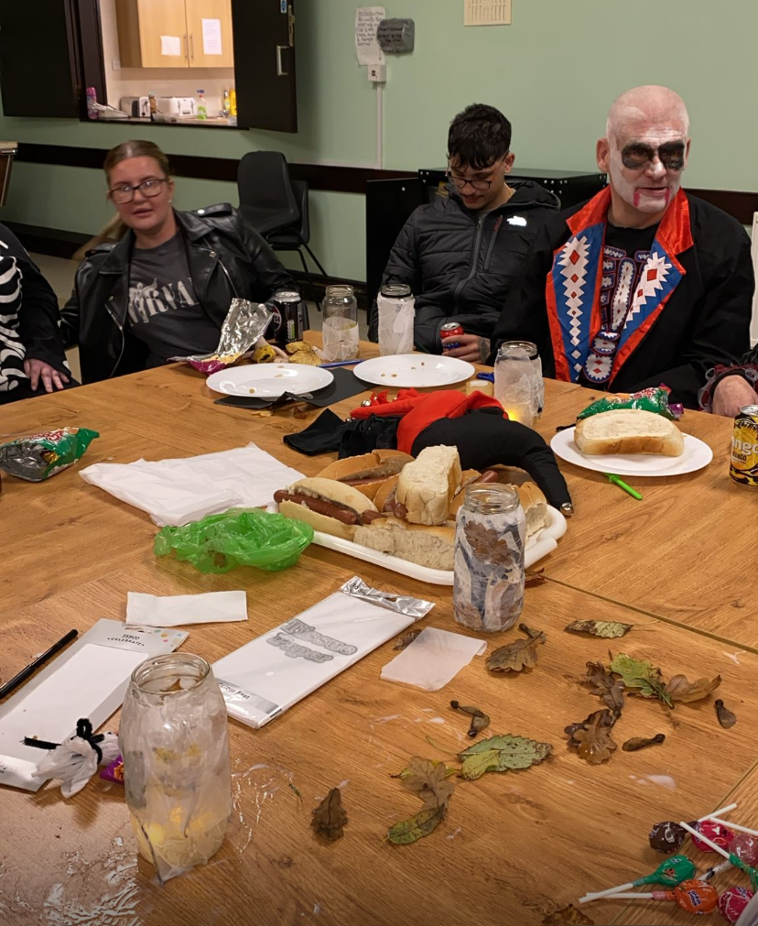
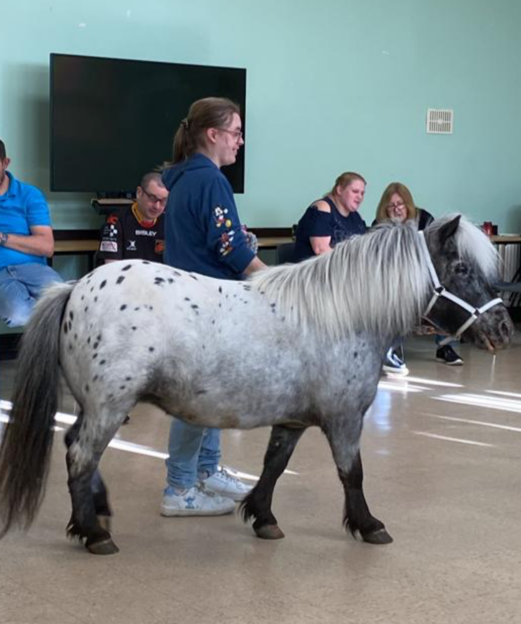
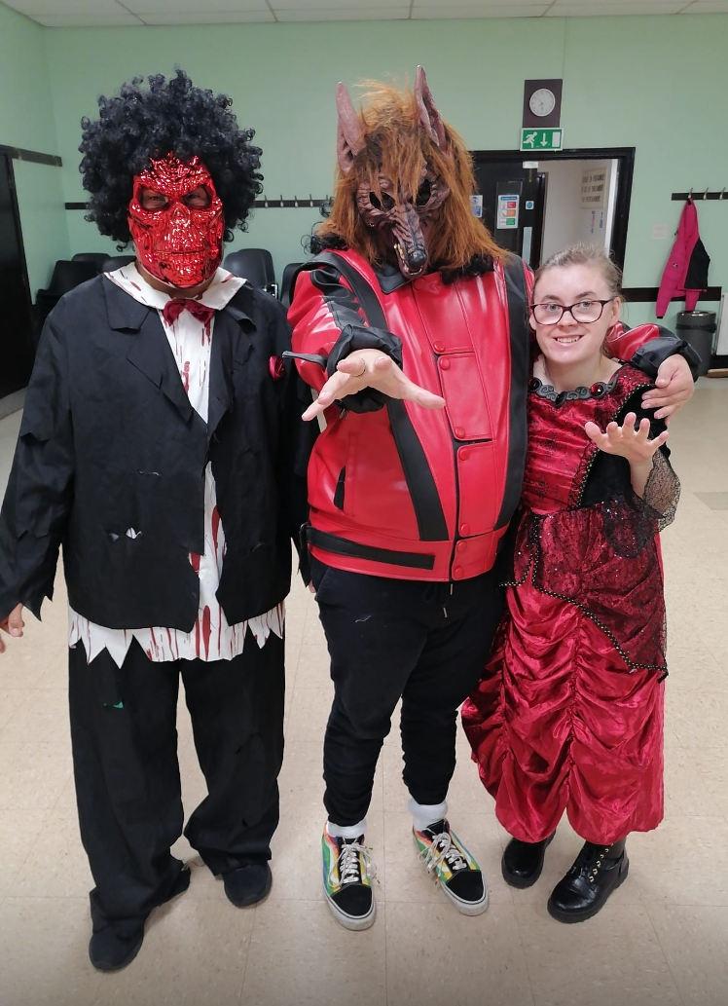
Looking for a new activity
Would you like to meet like minded people

Come join our social group chance meetings wales
For adults with additional needs.
Every Thursday 6pm to 730pm
Underwood community centre, underwood, llanmartin, newport NP18 2EQ
£3.00 per session
Lots of fun activities for adults 18 years old and above
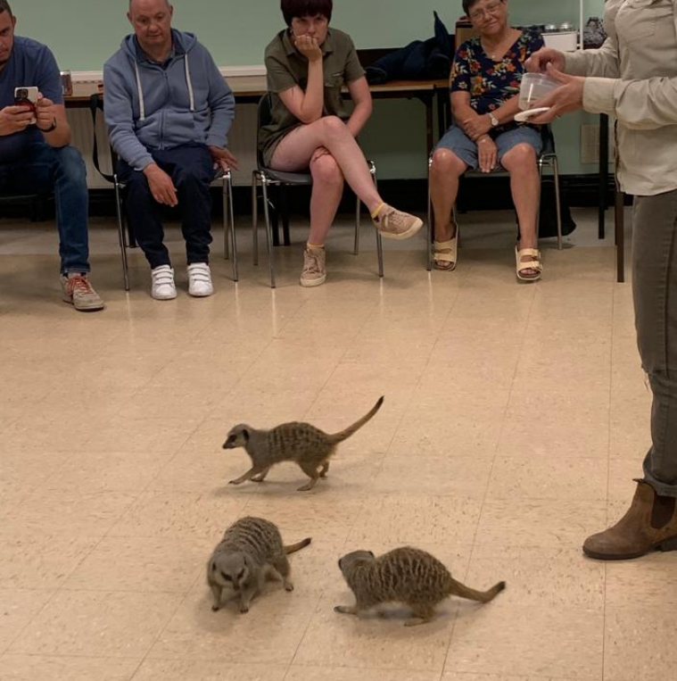
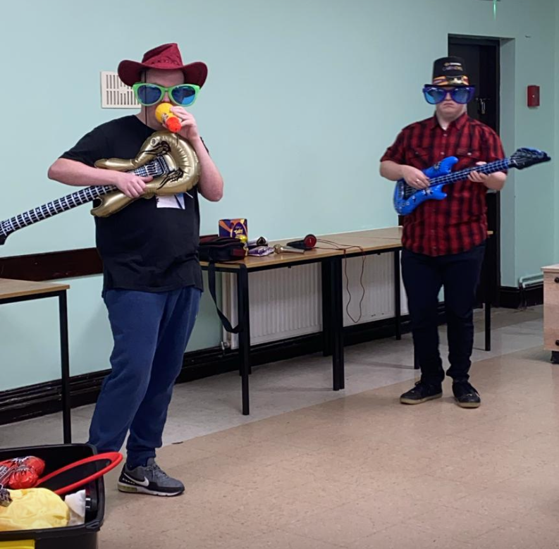
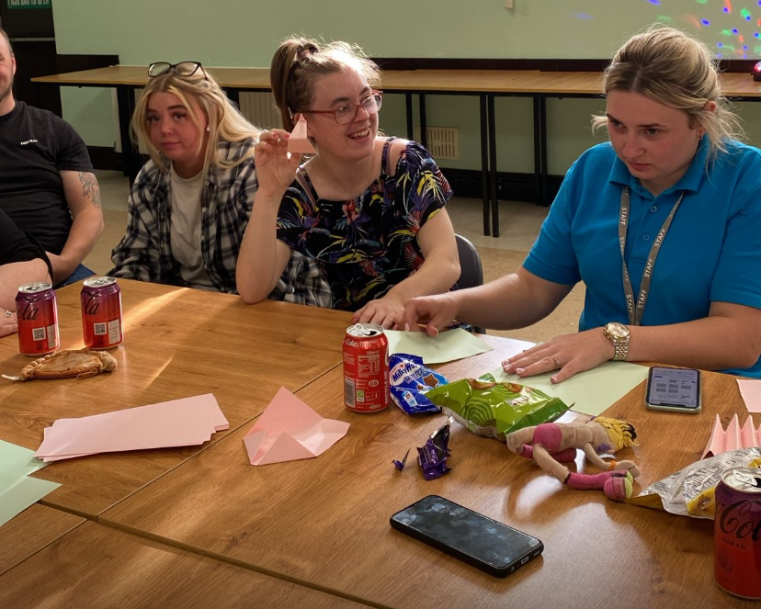
CONTACT KERRY 07860119393

