


Standard Operating Procedure for Test and Post (TAP) Service for community distribution through the Ageing with Intimacy Project

Purpose and Summary of Document:
This Standard Operating Procedure (SOP) outlines the generic process, roles and responsibilities for staff supporting the promotion of the Test and Post (TAP) home testing service across Gwent communities, through the Ageing with Intimacy project. The aim of this is to improve access to STI testing for older adults; supporting them to protect their sexual health and wellbeing.
This SOP is to be used in conjunction with other relevant SOPs, guidance and employer policies and procedures.
Authors:  Contributors:  Authorised by: | Bethan Ridsdale, Senior Public Health Practitioner  Daniel Clayton, Principal Public Health Practitioner  Katherine Hawkins, Policy Officer: Age Friendly Communities  Anna Morgan, Deputy Head of Public Health
Date: 25/02/26
Version: V0c

Contents
1. Background 3
2. Purpose 4
3. Scope 4
4. Objectives 4
5. Eligibility 4
6. Confidentiality and Privacy 4
7. Safeguarding 5
8. Role and Responsibilities 5
Process 6
9.1 Distribution 6
9.2 Results 9
10. Stock Management 9
11. Data collection and feedback 9
12. Key Contact Details 9
13. Appendices 10

Background
Intimacy, wellbeing, and sexual health remain vital aspects of life at every age. Despite this, older adults often face unique challenges in discussing and accessing support related to these topics. Societal taboos, stigma, and a general reluctance to address matters of relationships in later life often result in silence and misunderstanding, leaving older individuals without the information or support they need to maintain healthy relationships and protect their wellbeing.

Newport’s Age Friendly Intimacy with Ageing Campaign aims to challenge these misconceptions and shine a light on the importance of intimacy and sexual health for older adults. The campaign looks to foster open conversations about healthy relationships, encouraging individuals and communities to talk openly and honestly about intimacy in later life. The campaign also looks to prevent exploitation and reducing the risk of sexually transmitted infections (STIs) among older adults. By providing accessible information and resources, the campaign empowers older individuals to make informed choices, practice safe sex, and identify unhealthy or exploitative relationships.

The Test and Post (TAP) Service was introduced in Wales in 2020 as a pilot to support continued access to STI testing during the COVID-19 pandemic. The service uses online ordering and postal delivery of testing kits for chlamydia, gonorrhoea, syphilis, HIV, hepatitis B and hepatitis C. Results are texted to individuals with direction for sexual health clinical treatment as required. The Test and Post Service is available to individuals aged 16 and over in Wales.

The number of individuals tested for HIV in sexual health clinics, primary or secondary care or through the Test and Post (TAP) Service has doubled over the last five years. In 2024, a total of 133,699 individuals in Wales were tested, of which 53% were female, 41% male. Home testing accounted for more than 18% of individuals tested in 2024.

Access to Test and Post kits across communities in Gwent, particularly through the Intimacy with Ageing project, will encourage regular testing of STIs and reduce stigma around testing of STIs and blood borne viruses (BBVs) such as HIV. It also provides an opportunity to improve education around sexual health and knowledge of local sexual health services; in line with the Intimacy with Ageing project’s goals and objectives.

Purpose
The purpose of this document is to set out the delivery, process and responsibilities of staff involved with the promotion and distribution of TAP kits via the Ageing with Intimacy project in Gwent.
This document will guide staff through the processes involved in providing an individual with a TAP kit for home use.

Scope
This document applies to all individuals aged 50 and over accessing the Test and Post service through the Ageing with Intimacy Project. This SOP should be followed, in addition to other relevant policies and procedures. This will ensure staff offering TAP kits feel confident, competent and safe to promote and deliver the TAP kit service, and do so, holistically and with consistency.

Objectives
To ensure:
- Appropriate and timely screening of Gwent residents for sexually transmitted infections (STIs)
- The delivery of valuable sexual health information to older adults in Gwent;
- Raised awareness of the free STI test and post service in Wales and the importance of STI testing;
- Reduction of stigma regarding STI testing;
- Increased accessibility to STI testing;
- Signposting to services/further information regarding sexual and reproductive health

Eligibility
- STI testing kits are available to anyone in Gwent aged 16 and over.
- Safeguarding procedures may apply in specific circumstances (E.g., at risk).

Confidentiality and Privacy
All staff should be committed to maintaining confidentiality and privacy at all times. The Test and Post Service is fully confidential. Personal details shared for test kit registration will be handled in compliance with data protection laws and will only be used for testing purposes. Results will be sent directly to the individual via text message or phone call on the number that the individual provides.

Safeguarding
All staff must work in accordance with the national Wales Safeguarding Procedures. The Procedures and related documentation are available from https://safeguarding.wales/en/.

Where a safeguarding concern is identified, this must be reported to the Gwent Safeguarding Team before carrying out your own organisations’ safeguarding procedures.

Local Safeguarding Board details can be found here: https://safeguarding.wales/en/rsb-i/rsb-i-r1/r1-p1/.

Any safeguarding risks or concerns identified in anyone accessing TAP kits through the Intimacy with Ageing project (aged 50 and over) must be acted on through a discussion with the Safeguarding lead within the employing agency and the appropriate onward referral made. The duty to report is the responsibility of the individual who identified the risk.

DBS Checks
DBS checks must be in place as appropriate/required for roles.

Role and Responsibilities
Individuals must:
- Work within their scope of professional practice and in line with their professional code of conduct;
- Be supportive, non-judgemental, welcoming, and inclusive;
- Ensure any necessary training has been undertaken prior to offering and distributing TAP kits;
- Maintain observation during all interactions;
- Identify and escalate any safety or safeguarding concerns or incidents to their management as soon as possible;
- Be responsible for the management and ordering of TAP kits and promotional materials;
- Maintain records on type and quantity of TAP kits distributed;
- Gain necessary consent for data collection and referrals where applicable.

Process
To begin offering the Test and Post Service, you must:
- Be supporting the Intimacy with Ageing project;
- Identify an appropriate area, which is confidential, to allow for individuals to have one-to-one conversations around sexual health and access the Test and Post Service.

9.1 Distribution
- Any individual accessing the Intimacy with Ageing Project can access TAP kits;
- Only one TAP kit per individual should be provided at any one time;
- Identify which TAP kit to provide; test kits are available for male, female and/or universal use. Attendees should be asked which kit they would prefer. No assumption should be made as to TAP kit preference;
- TAP Kits are to be used by the individual requesting them – inform individuals that they will need to undertake the test themselves at home and post the sample back in the prepaid envelope; no interaction is required beyond supplying the kit (except for if the individual would like you to read through the instructions with them first);
- Staff should discuss the Test and Post Service and explain how to use the kits including how results are received;
- Staff should provide information on sexual health, including condom use, consent, relationships, and the importance of STI testing;
- Staff can signpost individuals to additional services, if necessary (e.g. SECS team, drug and alcohol services).

Contents of TAP kits:
Kits are ordered from, and packed by, Public Health Wales and are sent ready to be distributed. Each kit will include:
- Clear instructions for collecting a sample (urine, swab, etc.);
- A prepaid envelope for posting the sample to a laboratory;
- Information on receiving and interpreting results, and what to do next.

There are six different test kits:

Female test kits

- White Vaginal Kit with Blood
• 3 site tests swabs for Chlamydia and Gonorrhoea: vaginal, oral, rectal
• Finger prick blood test for HIV, Syphilis, Hepatitis B and Hepatitis C

- Dark Grey Vaginal Kit without Blood is 3 site test swabs only

Male test kits

- Dark Green Penile Kit with Blood
• Urine collection kit
• 2 site test swabs for Chlamydia and Gonorrhoea: oral, rectal
• Finger prick blood test for HIV, Syphilis, Hepatitis B and Hepatitis C

- Light Green Penile Kit without Blood is Urine and 2 site test swabs only

Universal test kits

- Red Universal Kit with Blood
• Urine collection kit
• 3 site test swabs for Chlamydia and Gonorrhoea: vaginal, oral, rectal
• Finger prick blood test for HIV, Syphilis, Hepatitis B and Hepatitis C

- Purple Universal Kit without Blood is urine and 3 site test swabs only

When should individuals be tested:
Clinicians sometimes refer to ‘window periods’ when testing for STIs. The window period is the amount of time it takes from contracting an STI to it showing up as positive on a test.

Chlamydia and Gonorrhoea: It is recommended that an individual gets tested 2 weeks after unprotected sex if they think they may have contracted either of these STIs.

Syphilis, Hepatitis B, Hepatitis C & HIV: For a blood test, it is recommended that an individual gets tested 7 weeks after unprotected sex (7 weeks is the window period for HIV). Individuals should consider re-testing again 5 weeks later (12 weeks after unprotected sex) as the window period for syphilis, hepatitis B, and hepatitis C* is 12 weeks.

*Hepatitis C can take up to 6 months to show up as positive in a test, those at risk of contracting the virus are recommended to test again 3 months later (6 months after unprotected sex).

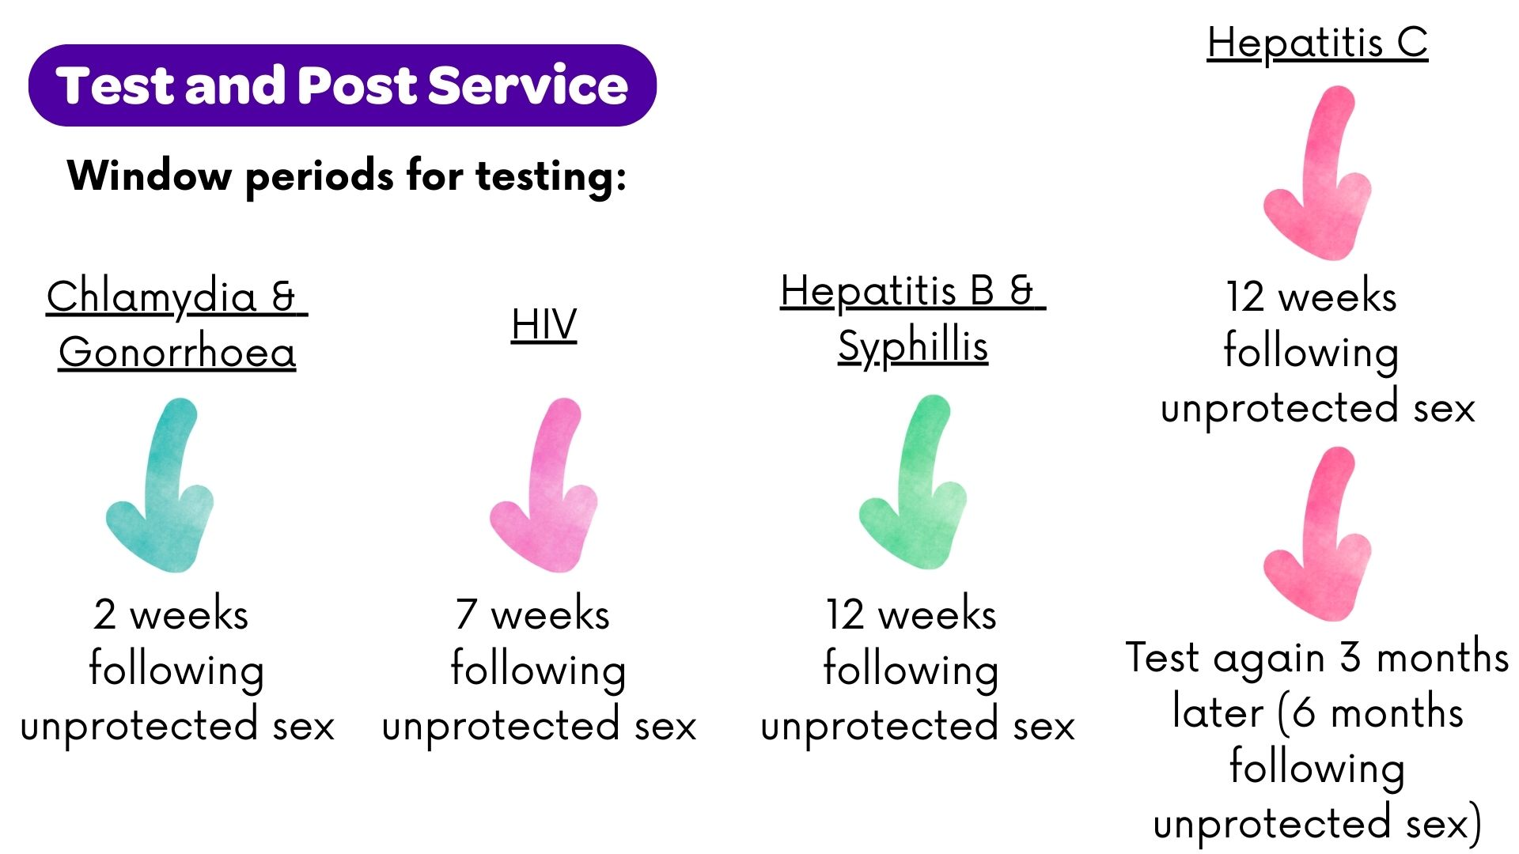

If an individual thinks they may have been exposed to HIV in the last 72 hours, it is recommended they seek immediate advice via their local Sexual Health Clinic. Individuals can make an appointment with their local clinic by calling 01495 765065. Details on local Sexual Health Clinics can be found via the ABUHB Sexual Health Page.

For more information on STIs and TAP testing, assessors should refer to the STI information sheets and information about TAP testing available via Sexual Health (SH) Wales as required (see Appendix A).

Using a Test and Post Kit
Staff should familiarise themselves with the videos available on the @SHWales YouTube channel and use a demonstration kit to support individuals and/or signpost to the following;

- What's in your Test and Post and what you NEED to send back
- What the Test and Post kits looks like
- How to take a Finger Prick Blood Sample to test for HIV, Syphilis, Hepatitis C and Hepatitis B
- How to use a Vaginal Swab to test for Chlamydia and Gonorrhoea
- How to use a Rectal Swab for Chlamydia and Gonorrhoea
- How to use a Throat Swab to test for Chlamydia and Gonorrhoea

9.2 Results
Once a sample has been sent off, the lab will process the sample and results will be provided via call or text using the number provided by the individual completing the test. Public Health Wales process all results and are the first point of contact. Where a positive result is received, a clinical referral for follow up may be required. Individuals should expect a phone call from their local Sexual Health Clinic in the event of a positive result who will advise them on accessing treatment. This is also an opportunity for the individual to speak to a professional for further advice. All results should be received within 3 weeks. If there has been no communication within 3 weeks, this should be followed up by the individual via phw.sexualhealth@wales.nhs.uk.

Stock Management
Stock must be ordered via Public Health Wales (see Appendix B). Staff are responsible for maintaining stock of TAP kits, ensuring availability of female, male, and universal kits.

Data collection and feedback
In order to better understand our community and impact of introducing TAP kits to the Intimacy with Ageing project, quantifiable data may be collected. This includes, but is not limited to:
- Number of TAP kits given out; including type of kit ‘Male/Female/Universal’;
- Number of engagements around TAP kits/sexual health information and advice;
- Number of TAP kits returned for testing (PHW data).

Should any additional data be collected such as demographic details, or patient identifiable information for any follow up or sign posting, attendees should be informed of how their data is being used or shared and ensuring consent is obtained.

Any data collected will be stored securely in line with the health board’s information governance guidance.

Key Contact Details
For support, concerns and queries, please contact: ABB.HealthProtection@wales.nhs.uk

Any safeguarding concerns should be referred via: https://www.gwentsafeguarding.org.uk/en

Appendices

A. STI and Testing Information Sheets
About HIV - Sexual Health Wales
About Hepatitis A - Sexual Health Wales
About Hepatitis B - Sexual Health Wales
About Hepatitis C - Sexual Health Wales
About Syphilis - Sexual Health Wales
About Chlamydia - Sexual Health Wales
About Gonorrhoea - Sexual Health Wales
About Herpes - Sexual Health Wales
About Genital Warts - Sexual Health Wales
Wales STI Testing Kit - Sexual Health Wales

B. Test and Post Kit Ordering Form



https://phw.nhs.wales/publications/publications1/trends-in-the-prevention-diagnosis-and-treatment-of-hiv-in-wales/

